Phase 4: Beta Release: Environment sustainability: study the impact of air pollution

**Introduction**

Although many of us are aware of the most common pollution causing factors that is harming the air we breathe and the atmosphere, there is a room for identifying some of the new and uncommon pollutants and their level of impact on the mother nature. For example, CFCs and the methane gas produced by animal husbandry in various economies depleted the ozone layer considerably in past few decades. In this project such causes along with other common causes will be highlighted and the impact will be studied.

**Objective**

The study intends to help the user to visualize the increase and decrease of air pollution level and its causes at various parts of the world over a period of time.

**Dataset**

The data has been taken from <https://www.airnowtech.org/data/>. The dataset contains various levels of pollutants in air for various areas in Maryland.

Other source of data is <https://mde.state.md.us/programs/Air/AirQualityMonitoring/Documents/MDNetworkPlanCY2020.pdf> to plot the latitudes and longitudes of the sites on the world map using geo scatter bubble plot.

**Prototype**

Figure 1: Global map and popup window to select the region of study

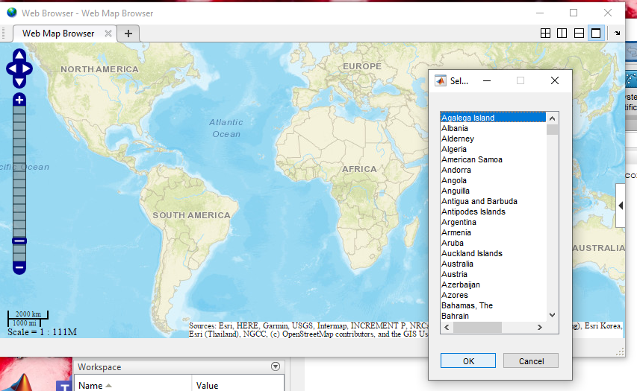

Figure 2: Reference scale of cloud cover percent

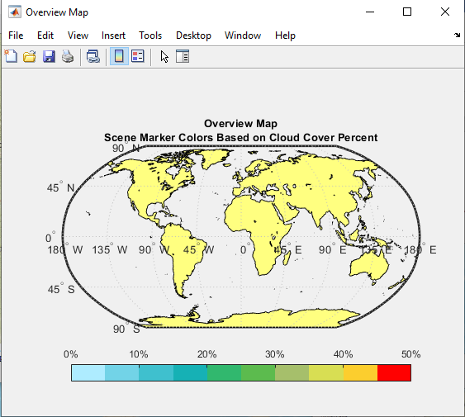

The two sites Edgewood and Essex are taken into consideration to study impact of air pollution. The contents of air like oxygen level, methane, carbon monoxide etc. are taken from data and the average is derived across a period and plotted on geo scatter plot. The study approaches the implementation as follows:

Interface 1:  This is achieved using MATLAB base map. Each region is highlighted with the following details:

* Latitude and longitude points for the site has been first bubble plotted on the base map.
* Concentration of pollutants like methane, carbon monoxide is plotted in map and the scale varied from green to red based on the increasing level of pollutants at the region.

Figure 3: Each marker represents various data attributes for that region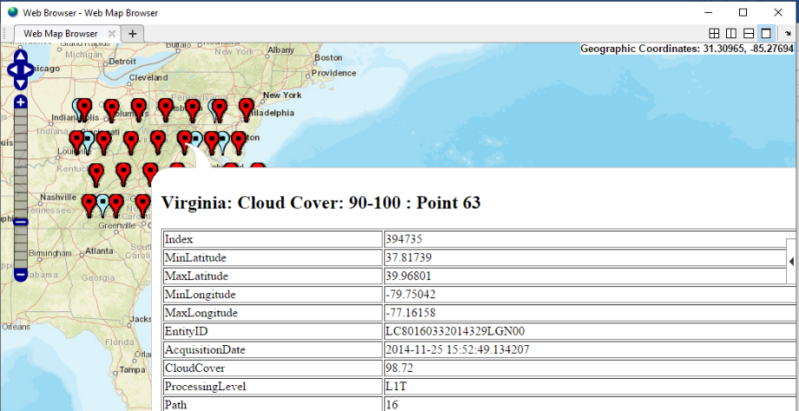

Click event on the map points will lead to a new window – interface 2.

Bugs: The data currently used is not the actual data from the source and a dummy data has been plotted. The data from the source will be filtered and plotted in a similar way.

Interface 2: Clicking on the region node will open a new interface representing pollution level of that region across (say 5) decades. An animated plot based on time series data will be included and research about pollution related activities in the area will be covered in interface 3.

Enhancement - the activities affecting the pollution levels depending upon the data we have. If the level reduces over a range, we also intend to include data about the measures taken in that region. We are planning to develop interface 2 in VR or Unity or Animated mode.